Sharing or embedding a specific time of a video is really helpful and be it is very effective to point out a specific topic from a long-time video. As like certain part of a part of the video. For example, let’s say you want to share a specific part of a YouTube video.

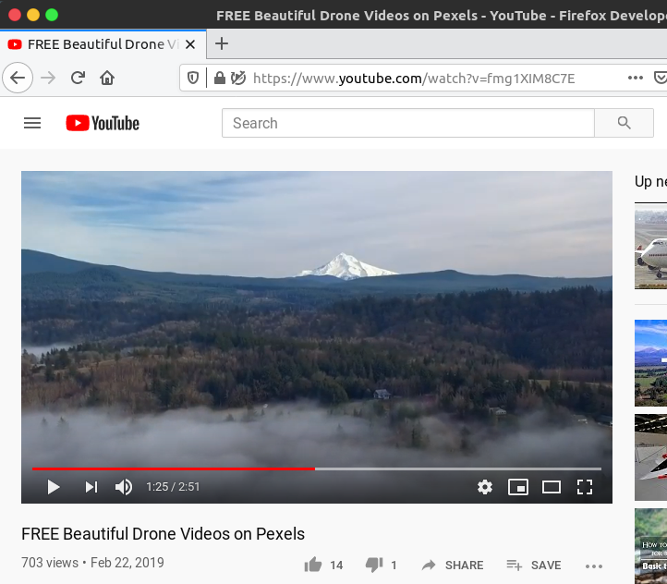

**Step 1:**

Go to the YouTube video that you want to embed or share.

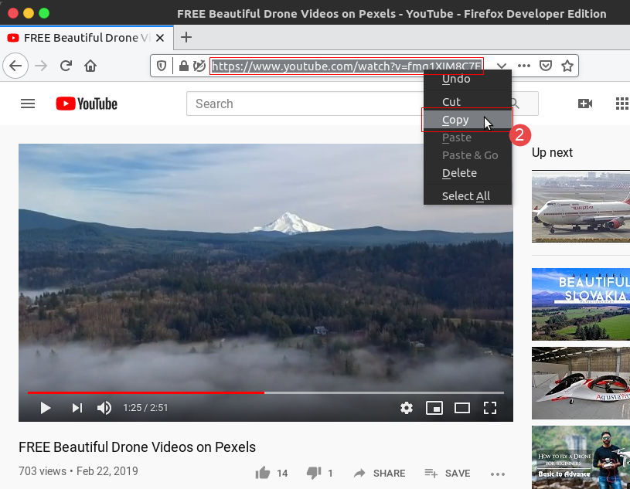

**Step 2:**

Copy the URL and paste to a Text Editor like Notepad, Notepad++ or SublimeText.

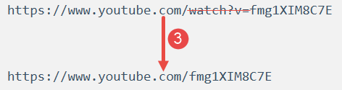

**Step 3:**

Remove the **“watch?v=”** part of the URL.

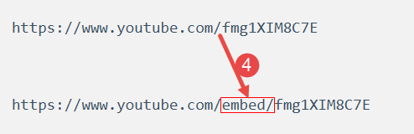

**Step 4:**

Add **“embed/”** right after the **“.com/”**.

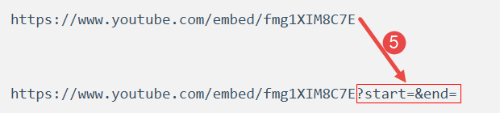

**Step 5:**

add **“?start=&end=”** time

Now append the start and end key as query string key of the URL those values are time of the video.

**Step 6:**

Watch the video and identify the specific start time and end time in seconds. Let’s say you want the video to start at 1 minute 25 seconds and end at 1 minute 51 seconds.

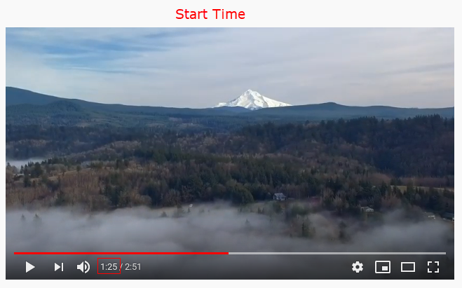

To achieve this, you need to include the following parameters into the embed URL – start=85 and end=116

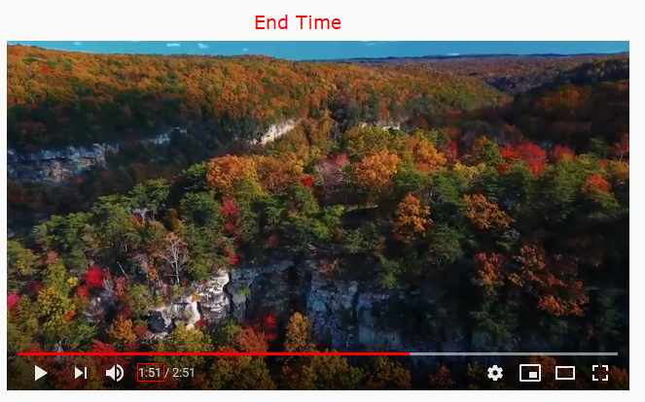

Calculate the time intervals for the video.

Make sure you calculate your start and end times into seconds. Get a [time calculator to convert](https://www.calculateme.com/time/hours/to-seconds/) your minutes into seconds. For example, if you want to start your video at 1 minute and 25 seconds, your start time will by 85 seconds.

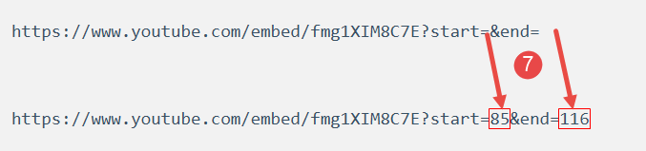

**Step 7:**

Add the time intervals to your YouTube URL then the final embed code will be as like follow:

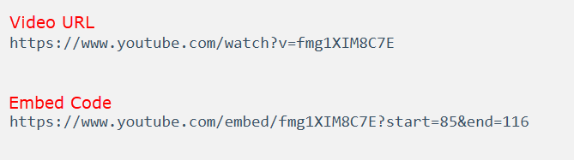

This will give you an embedded YouTube video starting at 85 seconds and ending at 116 seconds with a total run time of 31 seconds.

In this way, you can create your own videos with different start and end time. You can also choose to only have a start time or an end time by using only the start or end parameter in the URL.

You can see all **YouTube** parameters from [here](https://developers.google.com/youtube/player_parameters#Parameters).